Guardian Angels Church Restoration Project
Fall 2009- Fall 2016
Fun Facts
- Fall 2009 -- Patrick Sieben’s first laptop project presentation at Guardian Angels under Fr. Jarvis, Church staff, Architect and interested Parishioners.
- Early 2010 decision is made to tuck point entire North Campus rather than repair visually damaged/deteriorated/improperly-repaired areas.
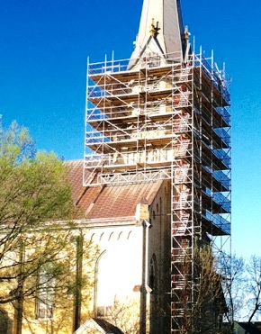
- First estimate from Building Restoration Corporation (tuck pointing only) and no
brick replacement on the Church, Friary and Courtyard wall is ~ $1.2 million.
- Solid Restoration & Masonry, Inc. (Patrick’s Co.) submits quote for ½ the original quote/estimate including brick replacement based on visual damage.
- There were 2,600 brick replaced in the Bell Tower.
- For the entire project Patrick replaced more than 19,000 Chaska brick.
- To visualize 19,000 bricks imagine 1½-semi flatbed trailers of brick.
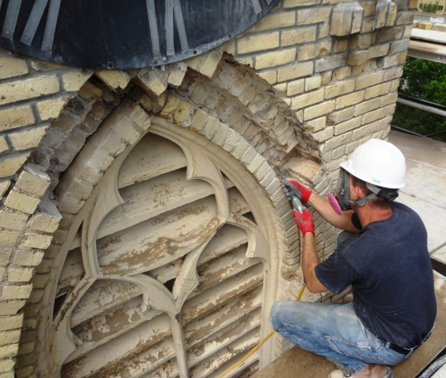
- Or visualize 19,000 brick placed end to end for 2.4 miles.
- Roughly 225,000 Chaska brick make up the surface area of the Church, Friary and Courtyard wall.
- Patrick estimates there are 1,225,000 Chaska brick used on the North Campus (Church, Friary, Courtyard wall).
- The Bell Tower structure is 5 brick courses thick, not including the pilasters.
- The footings for the Church, Friary and Courtyard walls are set on sand.
- Cost to erect the Bell Tower scaffold for 2 months work was $100,000.
- As part of the project, St. Anthony and St. Francis statues located high above the front Church entrance were rebuilt and repainted and are of unique metal construction. Interestingly, they lean significantly outward toward the street and were not fastened to the Church.
- Total Project cost for tuck pointing, the courtyard wall stone caps, Cedar Street
wall rebuild and 19,000 Chaska brick: $800,000.
- Current contract work completed fall 2016, 7 years after initial project
presentation.
- Not one dime borrowed for the project because of “Pay As You Go” approach.
Special Note
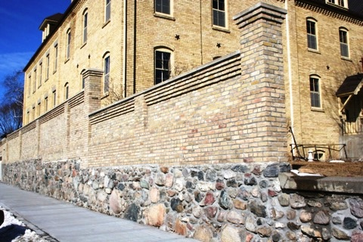
The Church’s front steps were not included in the contact because at the time the City of Chaska had not firmed up plans for the Second Street reconstruction and utility work. There were unanswered questions as to whether or not the existing curb and sidewalk by the steps would be replaced. Entwined in the potential curb/sidewalk removal is the fact that the stairway snowmelt system is combined into the sidewalk. Uncertainty with the City’s intentions made it difficult to plan for restoration.
Patrick rebuilt much of the east, north and Cedar Street top portion of the courtyard wall to corbel out four brick so that the wall appearance is the same around the entire perimeter. In doing so, only one size stone cap was required verses the purchase of at least 4 or 5 different sizes. The cost savings to GA was $10,000. The work took 6 weeks to complete and there was no additional charge for the work.
Compiled and written by Leo J. Forner, 31 August 2016
Relentless Commitment, Passion & Craftsmanship
Mr. Patrick Sieben
Building Restoration Project
2009-2016
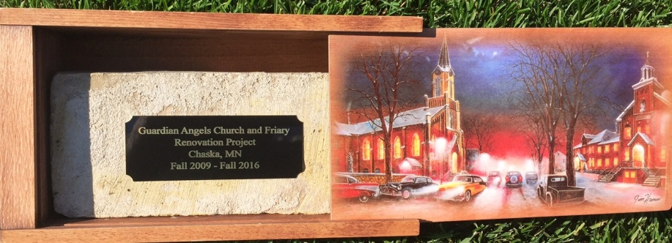

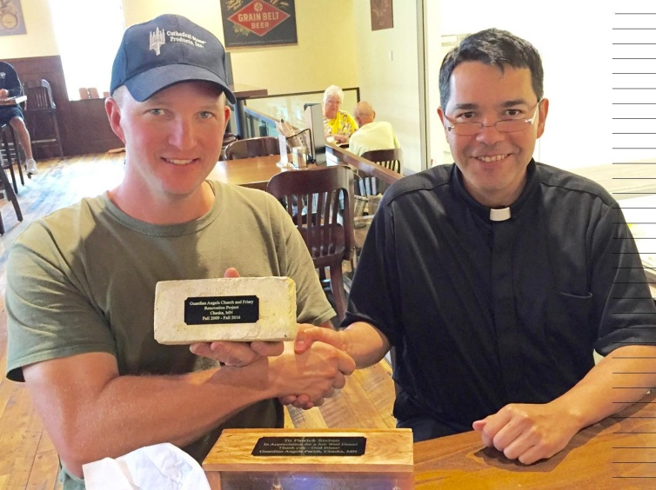

A token of appreciation for
accomplishing a landmark
project. Congratulations!

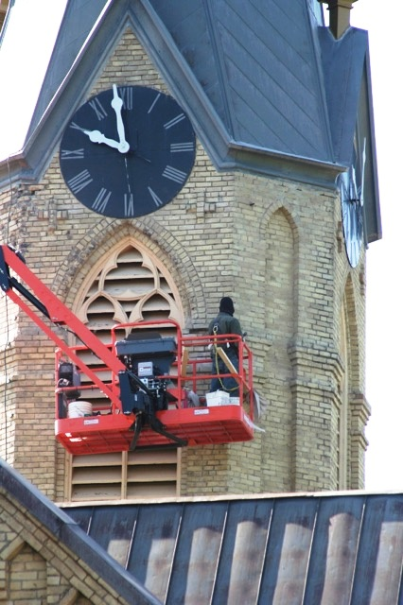
A Few Words from Patrick…
“I don't really know what to say to everyone at Guardian Angels except "Thank you." It's been a very blessed experience to do the restoration of your church. You have had to put up with my messes for seven years now and it probably felt like I would never leave. I certainly felt that way at times myself. The amount of work that has been done over the last seven years is amazing, and not just what I have done, but also the other projects as well. It is quite the transformation of a campus and I am blessed to have had my role in it. I hope that you are all able to take a look around, get some pictures of what things looked like seven years ago, and marvel a little bit at what you have all accomplished through your generosity. It is truly a great accomplishment and I am also able to sense that for myself. The Good Lord has blessed this project from start to finish. He has blessed it with great hardship and difficulties, and He has blessed it with great success in its' completion and in the relationships I've made with many of you. Thank you again and may God bless you in the future.”

